1. What did you contribute to the group? List skills as well as concrete tasks (e.g. presentation writing skills, design, coding, testing, etc.).

1)presentation writing skill;always try to take the task initiative so that there is less worries about slow beginning of task.finished the (non)functional requirement and give some reference about hardware and software platforms to be used for developing and running your solution.Then do improvement and modification after consulting Dr. Dan’s comment.After Christmas’ holiday,completed the package and class diagrams with Talen,updating the version and modified for several times.

1. design:brainstormed with members to design the font end and translated into paper information with talen.
2. code skill:learned a lot about html,css,js and basic understanding of cakephp.During the holiday,after talen finished the font end with axure.Using original html and js to achieve.Then master using gitlab to do version control and composer to install phpunit.
3. test:because the font end had not used,so undertook the mission of test coding.Taking lot of time on unitphp,then leading talen to coded test.As the test leader,I was mainly responsible for environment configuration and controller test then lead talen for the table test.Updated the code and method with cakephp Ver 3.xx ‘s and do the debug,also run the test.

5) database:help Peter to deploy the database,basically participated in the part while Peter tried to connect the database with online sever but not the school sever which can not work with the cakephp.Due to the question Peter met I had suffered before and already fixed it in my computer,I give effectively advise and point out where the problems and bugs came out.

1. Describe three things you feel you personally did well:
2. good communicate and positive on brainstorm,submit task on time.Always be strict on own part.Keep updating and modification the context and code for several times until I can not check out wrong or bug.
3. good patience while deployed the configuration of cakephp ,unitphp,database and would like teach others how to do it.Due to met many problems while deployed projects setting on both database and cakephp framework,quickly help Peter to fix quite a lot problems while he tried to build own database.

3) good test leader:After undertake the test part and noticed that should finished job without example,still need to lead others.Spend lot of time on learning testing from <https://book.cakephp.org/3.0/en/development/testing.html> and searched example on github.Complete the configuration of most thing in own computer so that talen can do the program without wasting time.After testcase finished,debug and figured out that some method were already obsoleted,replacing with new method matching to current version from cakephp API.Here is a testcase for table test.

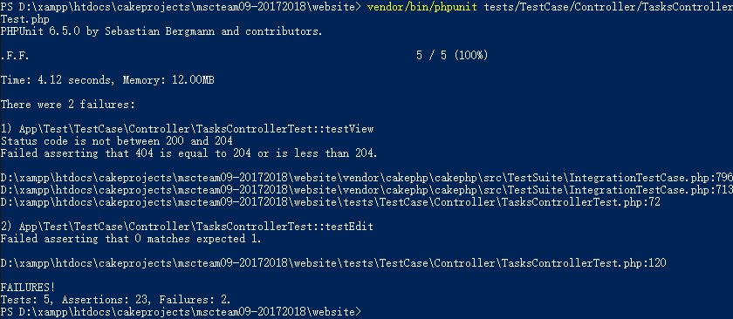

1. Think about the things you personally did not do so well. Identify three areas in which you would seek training as part of your continuing professional development.
2. Cakephp: not enough understanding about it,which made it difficult to understanding what craig had done and spent long time struggling run the website in own computer,although the there were some files missing while craig pushed to gitlab.But this became good experience helping deal with the database connecting problem from Peter.
3. Co-operation study:always learned alone,seldom asked others to study code or testing together.Seems like that want to be a expert leading others,hate falling behind the others.But it’s not good thing in group that make slow progress and low efficiency .
4. Font-end realize:I had follow the design did with talen to realize it with original html and js.it.But the version we did had not been all adopted because craig gave a better one with cakephp framework.I should do more preparation before starting code.Little understanding about cakephp at first resulted in that I can only code with basic knowledge.

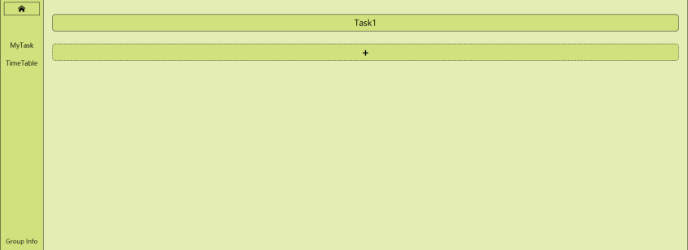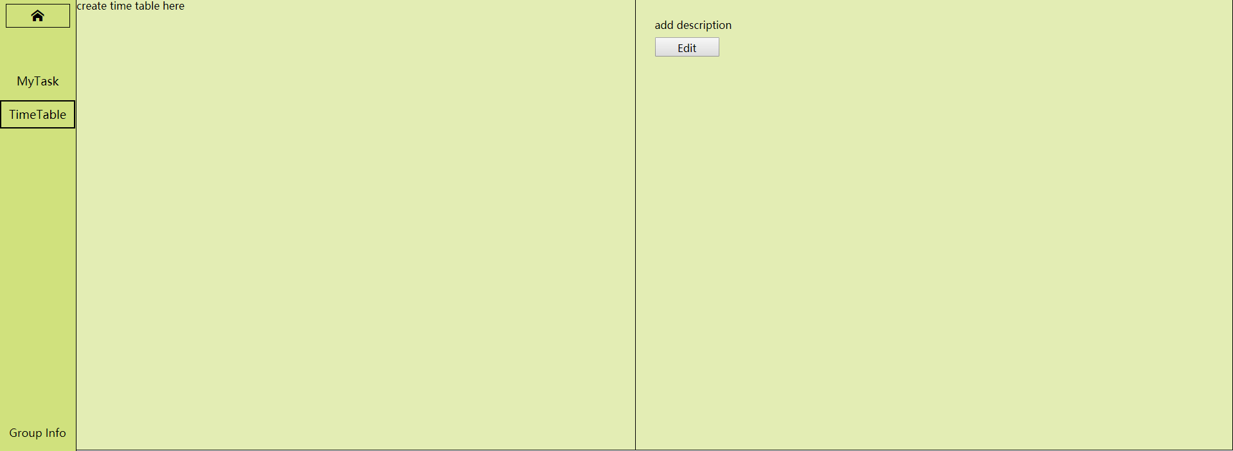

1. Identify the main thing the group could improve on if you were able to redo the project (0.5 pages)

If i were able to redo,I may want to evaluate everyone’s level on code or writing,which can make it easy to allocate the assignment.We had change our part during realizing the projects because the initial work assignment was quite not suitable.Because my part of font end was not adopted,I can only undertake the test job while the Jay and Dimitris had no idea about, also the abandon Peter’s work database at first.Maybe we need a common platform to code or write doc together,convenient to share idea together.Still a good way from other group without any experienced programmer,it is do everything together.I’ve heard that some group use the day with no lectures to take work together in USB,maybe someone take the responsibility to write code,and others can check the framework or give advice.This way is actually tired but nobody will feel trouble because we do together.Even you are noob on code,you still study,be stronger in the same place.By the way,we might need to be more strict because since the second semester begun,we can not contact Lee though whats app show that he already read the message,but never receive response.If we can notice this earlier maybe we can have better assignment to everyone.